CodeTrack Initial Git Set up
Olajide Kuti
Group 1
Assignment 8
Screenshot 1
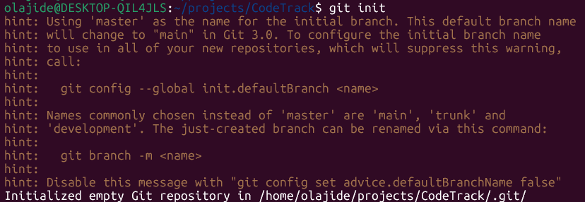
Screenshot 2
Screenshot 3
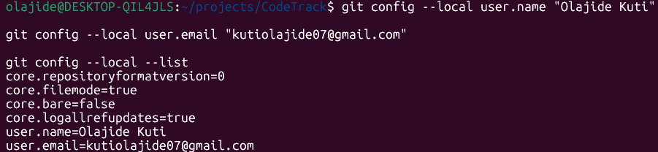
Screenshot 4
What is the .git folder and why does it matter?
The .git folder is a hidden directory that Git creates when a repository is initialized with the git init command. It stores all the information Git needs to manage the project, including the commit history, branches, configuration settings, and references to tracked files. The .git folder is important because it enables version control, allowing developers to track changes, restore previous versions, collaborate with others, and manage the project's development history. Without the .git folder, Git cannot recognize or manage the directory as a repository.
This explanation satisfies the assignment because it:
- Explains what the .git folder is.
- Explains why it matters.
- Is written in your own words rather than copied from documentation.
For future assignments and interviews, you can also remember this simple summary:
Think of the .git folder as the brain of a Git repository. It contains all the history and metadata that allow Git to track every change made to your project. Without it, your project is just a normal folder with files.

